We will do the same as in the previous exercise. Let's first create our partition table through the menu.
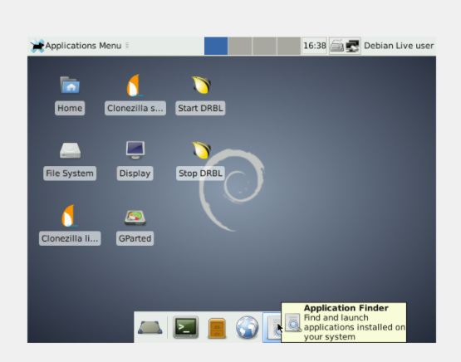

We are going to create a Primary Partition of 1GB, whose file system is FAT32 and its name is ONE.
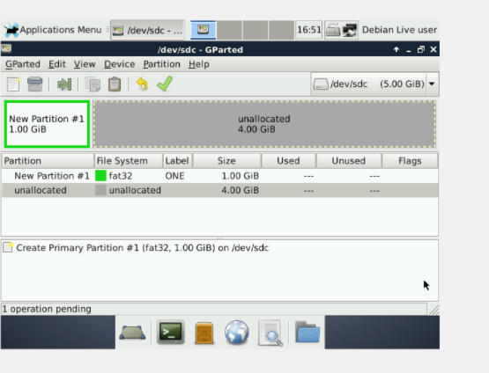

After creating an extended partition, we right click on the extended partition and create a 1 GB logical drive, which has NTFS file system and FOUR label.
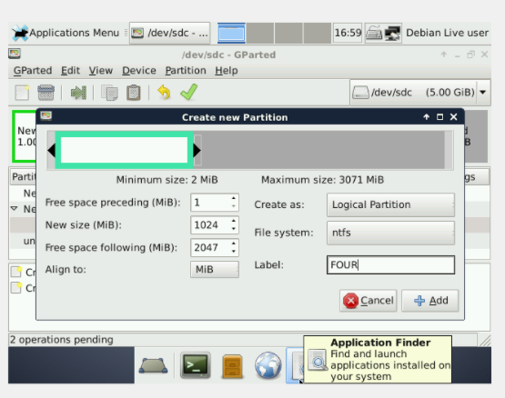

Then we will create another 1 GB logical drive, which has EXT4 file system and no label

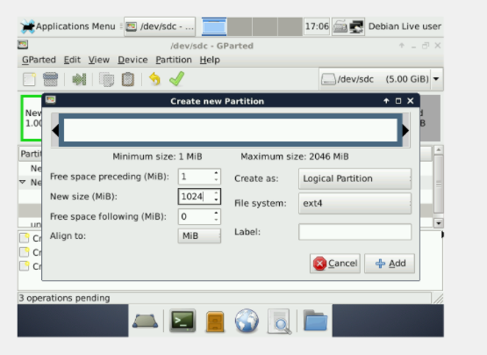

Another 512 MB logical drive, which has FAT32 file system and SIX label.
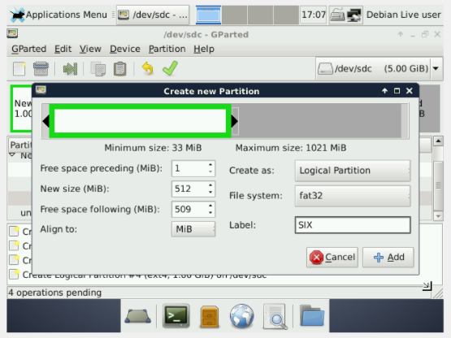

We will have a free space of 509 MB.
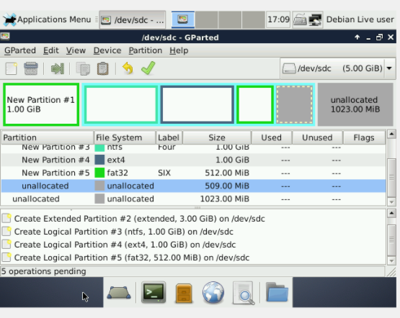

We create another primary partition at the end of 1GB, file system FAT32 and label THREE.
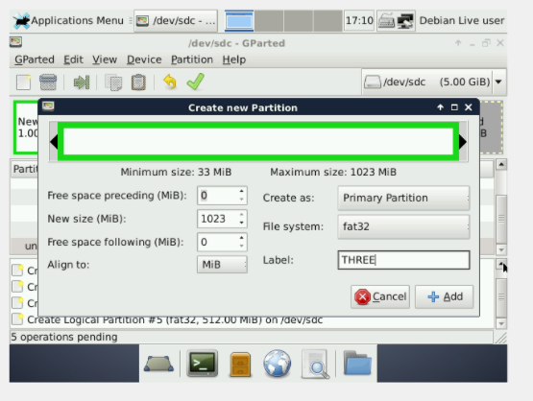

As a result, we will have 509 MB of unallocated space on the extended partition and 1 GB on each primary partition.
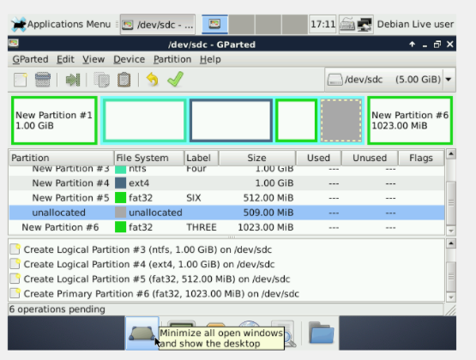
Answer the following questions

- How does GParted name the new hard disk?
/dev/sdc

- List all the partitions you have created, indicating type and file system.
- Primary: Label One, 1024 MB, FAT16
- Extended of 3.072 MB
  - Logical: Label Four, 1024MB, NTFS
  - Logical: Label Five, 1024GB, any non-Windows file system
  - Logical: Label Six, 512MB, FAT32
- Primary: Label Three, 1024GB, FAT32

